Postal Life Insurance

Department of Post

Software Requirements Specification (SRS)/ Functional Requirements Specification (FRS)
Premium Receipt Book

INTERNAL APPROVAL FORM

Project Name: Premium Receipt Book
Version: 1.0
Submitted on:
 | Name | Date
Approved By:
Reviewed By:
Prepared By:

VERSION CONTROL LOG
Version | Date | Prepared By | Remarks
1

Table of Contents

1. Executive Summary 4
2. Project Scope 4
3. Business Requirements 4
4. Functional Requirements Specification 5
4.1 Non-Financial Service Request Indexing page 5
4.2 Premium Receipt Book Page 6
5. Attachments 6

1. Executive Summary
This document defines the requirements for the Premium Receipt Book (PRB) module in IMS. It supports both digital and physical receipt workflows, ensuring compliance, traceability, and customer convenience.

2. Project Scope
The PRB Module will:
- Generate digital receipts for all premium payments.
- Deliver receipts via customer portal, mobile app, and SMS.
- Allow optional physical PRB issuance in rural/non-digital areas after taking due charges.

3. Business Requirements

ID | Requirements
FS_PRB_001 | System shall auto-generate a digital premium receipt upon successful payment.
FS_PRB_002 | System shall send the receipt via SMS and make it available on the portal/app.
FS_PRB_003 | Physical PRB shall be issued only if the customer pays required fee.
FS_PRB_004 | lease delete this row
FS_PRB_005 | Each receipt shall be unique .
FS_PRB_006 | System shall maintain a searchable digital archive of all receipts.
FS_PRB_007 | System shall allow branch/post office staff to view, print, or scan PRBs.
FS_PRB_008 | System shall support reconciliation of physical and digital receipts.

4. Functional Requirements Specification
Flow Diagram for Policy Receipt Book Process: 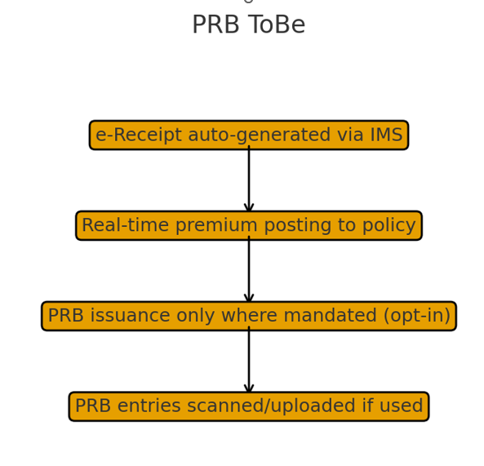

4.1 Non-Financial Service Request Indexing page
- Purpose: To create Non-Financial Service Request for Premium Receipt Book on obtaining due fee.
- Fields:
  - Request Type: Option should include service request type like Premium Receipt Book, etc.
  - Service Request Date: Calendar: Date on which service request is indexed.
  - Policy Number: Text
  - Office Code: Text: Facility ID of the office where request is getting indexed
  - Service Request Channel: Text: Channel for the service request like RICT, CP etc.
  - Username: Text: Emp ID of the user indexing the request
- Rules:
  - Request should get created and CPC User should be able to open the details.

4.2 Premium Receipt Book Page
- Purpose: To download the Premium Receipt for the Policy.
- Navigate to “Premium Collection” → “Manual Receipt Entry” or similar module.
- The user should be able to search the premium receipt using following details:
  - Policy Number
  - Customer Name
  - Amount Paid
  - Date of Payment
  - PRB Book Number
  - Receipt Serial Number
  - Payment Mode
- The Premium Receipt should be downloaded in PDF Format.
- The Online Premium Receipt can also be sent to Customer using Email, SMS and WhatsApp channel also.

5. Attachments
The following documents can be referred.

